Ryan Ford

UI Project

1) Imaginary Users

a. Mr. Adult is a father of 2 twin boys and a husband to Mrs. Adult. Mrs. Adult works long hours for a DOD contractor, so Mr. Adult does most of the looking-after the kids who are just starting high-school. He has downloaded the CHORE-TRACKER™ to help the boys and himself keep the house clean and shipshape. He plans to use the rewards to manage both the house and the boys’ growing interest in videogames.

b. Ross is the older of the twin boys (by 5 minutes). He keeps on top of his schoolwork and is starting advanced math classes this year. He joined the Track team at his school, and gets home around 2 hours after his brother. Ross’ room is messy, but his desk and workspace are generally in order. After school and Track, he eats dinner and works on his homework before relaxing. Ross has downloaded the CHORE-TRACKER™ on his phone, and feels it’s a bit patronizing for someone his age, but is generally willing to play along. He completes the smaller tasks to get them over with, or waits until weekend mornings to get larger tasks done. He uses the points for his free evenings so that he can finally get the computer from his brother Joey to play games.

c. Joey is the younger of the twins. He lacks motivation to do any better than to avoid punishment for bad grades, and spends a lot of time on the computer playing games. Joey is pretty against the CHORE-TRACKER™, and feels that it is just another way for his parents to control him. Joey, however, has realized that there is no winning a fight with the people who own the house he sleeps in, and wonders how difficult it would be to break the software or get it to glitch as an excuse to not do the chores. He works on the time-consuming tasks for more points and as an excuse to not have finished his homework. Joey uses his points to stay up late and play online with his internet friends. He will also exploit small flaws in the system, such as “finishing” a chore and using the points to justify taking the computer from his brother before Mr. or Mrs. Adult get home and realize the chore isn’t really done, or helping his brother with a chore and marking it done so that he gets all the points when they should really be split.

2) User Model

a. *Overview of the System*

The CHORE-TRACKER™ app is an application for your phone which allows a family to keep an up-to-date record of chores that need doing and rewards for completing those chores. Each family member, or user, will have their own account which they can log in to from their phone. Parent users can create and delete chores as well as set point values to each task. Child users can view the list of chores to be done, see how many points each chore is worth, and mark chores as completed. Once a child marks a chore as completed, their account receives the amount of points that chore was worth. Parents can also post rewards which can be purchased with the points earned from completing chores.

b. *Functionality of Child-users marking chores as complete*.

1. How would this feature work for you?
2. What should you be able to do?
3. What should you not be able to do?

Focus Group: CaraMarie (*Girlfriend*), Chandler (*Roommate*), Joey (*Friend*), Kent (*Father*)

*CaraMarie*:

1. This seems pretty straightforward, but has potential for abuse. I know my younger brother would “clean” his room and just put everything in his closet, or something like that. Maybe parents should be able to take away points or rewards.

2. I would want to claim a reward and use the points right away, or maybe have a reward attached directly to a chore instead of using the point system.

3. I don’t think kids should be able to mark a chore as done, but it makes sense if parents are away often. I think parents should mark chores as completed, or they won’t be done to their standard.

*Chandler*:

1. I want to be able to press the button for completing chores and get points. It sounds like it would work well for me.

2. I should be able to mark chores as completed to get points, but only after I’ve completed the chore. Maybe I could take a picture of the “cleaned room” or completed chore and sent it to my parent for confirmation.

3. I would lie and “complete” the chores for points. I probably shouldn’t be able to do that. Maybe I should only be able to get one reward each day to prevent abuse.

*Joey*:

1. This would work well for me because my parents didn’t get home until late. If I had to wait for parents to mark chores as done, I wouldn’t do the chores until right before they got home.

2. I should be able to split the points with my sister, maybe that would get siblings to work together more.

3. I don’t like the idea of “claiming” a chore. I have a roommate who doesn’t take out the trash as often as he should, and I could see kids doing the same thing where they don’t do the dishes until right before the deadline. Are there deadlines?

*Kent*:

1. This would work well for me because it means I have to do less on the app; I don’t have to micromanage the points or really get too into the app, just put up chores and rewards.

2. I should be able to set deadlines. I want the dishes done BEFORE I get home, or I would reduce the points they receive. I also want to be able to revoke points if a chore isn’t done as well as I wanted. I might also want to assign chores to specific children.

3. I wouldn’t want kids spending points before I confirm that the chore is done.

c. *User Model Paragraph*:

The users all assumed the login/welcome screen would be the first thing they see. Some wondered if the family would all use the same email, expecting younger kids to not have their own email yet. They assumed that Parents and Children would have separate options and therefore see separate menu screens. They were all familiar with how most apps look, so they described “menus”, one specified “like a restaurant” with the chores on the left of the screen, and point values on the right. They assumed that most of the buttons and options would start from the top of the screen, but we’ve tried to put a lot of the UI lower down closer to where the thumb rests. Users expected a “home” screen where they can navigate to separate screens for each task; the Create Chore function would be all on one screen, then go back to the home screen, then go to the Create Reward screen. They expected similar modularity for the Child functions.

3) Prototype Image:

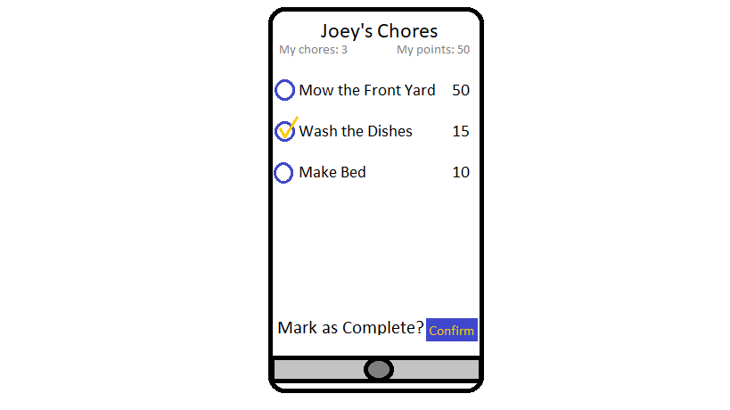

4) Feedback:

Most users responded that this is pretty much what they expected to see. Some didn’t like the colors used, or wanted a “better” aesthetic. Helpful comments pointed out that the language could be more simple for children; “confirm” and “complete” might be simplified. One user pointed out that a “cancel” or back button might be needed.

5) Changes in Response to Feedback:

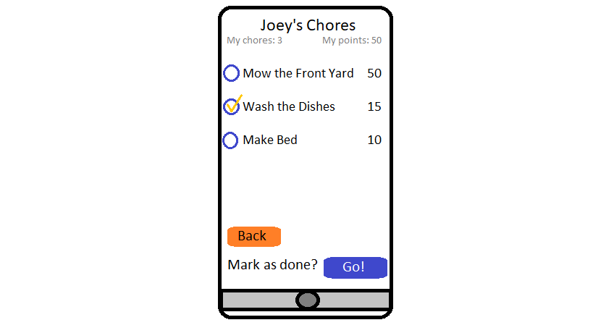

a. Explanation

I agreed that the language could be simplified. I’m not SUPER happy with where the Back button is, but I wanted it far away from the Go button to avoid accidental cancelation.